|  |
| --- |
| MTU Kerry |
| Artificial Intelligence: Genetic algorithm to complete a 2D platformer level. |
| Academic Year:2024/2025  Programme Title: Computing with Games Development – MT803  Module Title: Artificial Intelligence  Module Assignment: Assignment 1: Genetic Algorithm  GitHub: [Github Link](https://github.com/Billy-Elsbury/2D-Platformer-Unity)  Module Code: COMP 81000  Lecturer’s Name: Robert Sheehy |

|  |
| --- |
| STUDENT Billy Elsbury T00224562 |

Contents

Genetic Algorithm: 2

Brainstorming For Genetic Algorithm: 2

The Problem (~30%) 2

Description of the Problem 2

Discussion of the Suitability of Genetic Algorithms 2

Complexity of the Problem 3

The Problem and the Cost Function (~20%) 3

Fitness Function Code 3

The Individual (~30%) 4

Chromosome Representation 4

Crossover 4

Mutation 4

Code for Individual Class 5

Running the Algorithm (~10%) 6

Parameter Choices 6

Genetic Algorithm Execution Code 7

Results and Conclusions (~10%) 8

Results 8

Challenges and Limitations 8

Conclusions 9

Future Directions 9

Issues Discussion 9

Unity Project Creation Process: 11

C# Genetic Algorithm Explanation 11

Genetic Algorithm Completing Level Example 13

Genetic Algorithm Running Demonstration 13

List of Figures 15

References 16

# Genetic Algorithm:

## Brainstorming For Genetic Algorithm:

**Pathfinding for 2d platformer:**

*Could I make/find a platformer in Unity and then put in my own best time and aim to have the algorithm beat my time?*

**Problem**: Generate a set of inputs that will get a character the furthest in a 2d platformer game.

**Modifiers**: fitness cost could be determined by how far the character gets in the level, time taken, and number of obstacles avoided. There could be a slight penalty for jumping to discourage unnecessary jumping.

**Chromosome:**

A sequence of actions for the character to input, left right, jump. More?

The time delay between inputs would be represented in the chromosome.

**3 bands or channels with on or off for each keypress**

cost function related to the closest distance to the goal.

if (newDistance < bestDistance){bestDistance = newDistance}

**Crossover:** Combining segments of actions/inputs from two-parent solutions to create offspring.

**Mutation:** Randomly altering actions/inputs to find new possibilities/shortcuts.

# **The Problem (~30%)**

## **Description of the Problem**

This project applies a **Genetic Algorithm (GA)** to train an AI agent to move efficiently through a level in **Unity**. The AI controls a **player character** that can move left, right, and jump. The objective is to optimise movement such that the AI reaches the goal as quickly as possible while navigating the level safely.

The AI learns by evolving movement sequences (chromosomes) across multiple generations, with the best chromosomes being selected for further refinement.

## **Discussion of the Suitability of Genetic Algorithms**

A Genetic Algorithm is suitable for this problem because:

* The search space is large, as movement sequences can vary in timing and direction.
* A **deterministic approach** (e.g., brute force or traditional search trees) would be computationally expensive due to the number of possible movement combinations.
* GAs allow for **continuous optimisation**, evolving better movement strategies over time.
* The problem has a **clear fitness function** (distance travelled + goal completion time), making it easy to evaluate individuals.

## **Complexity of the Problem**

This problem is moderately complex because:

* The AI needs to determine **when** and **how long** to move or jump.
* The physics engine introduces variability in movement outcomes.
* The agent must **balance exploration and exploitation** to avoid suboptimal behaviours.
* A **suitable fitness function** is critical to prevent unintended behaviours (e.g., idling or dying at the right time).

# **The Problem and the Cost Function (~20%)**

## **Fitness Function Code**

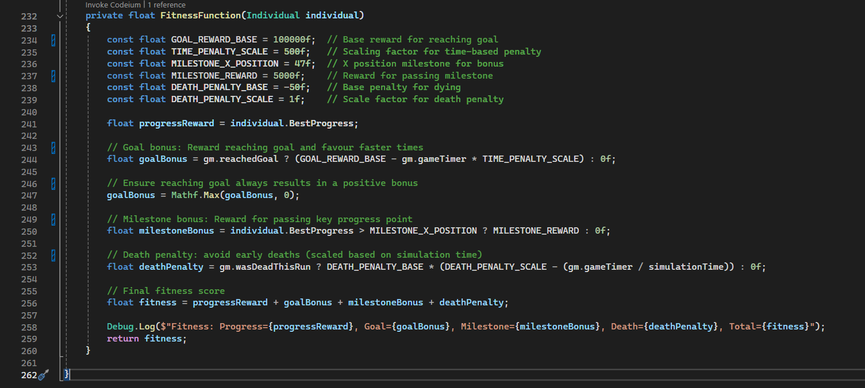

# **The Individual (~30%)**

## **Chromosome Representation**

The chromosome is a **floating-point array (**Figure 1**)** representing a sequence of movement actions. Each gene in the chromosome corresponds to an action (right, left, jump) with the value of the floating point number representing the time to hold that input.

This sequence was initially split evenly between the three possible inputs, in later testing the sequence was split using 60% right, 30% left and 10% for jump inputs to encourage more consistent right inputs while allowing some left inputs for minor corrections and jumps should only be present sparingly.



Figure 1: Chromosome Example

## **Crossover**

A **blend crossover** is used, where two parent chromosomes generate offspring by mixing their genes with some exploration variability.

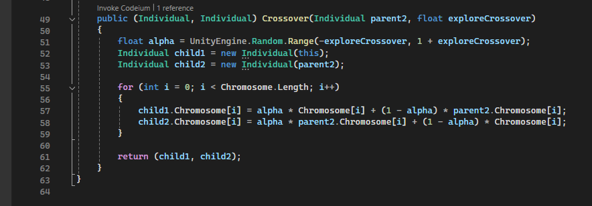

## **Mutation**

A small mutation is applied to **introduce randomness**, preventing the algorithm from converging too early.

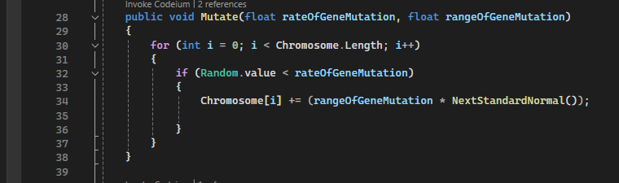

## **Code for Individual Class**

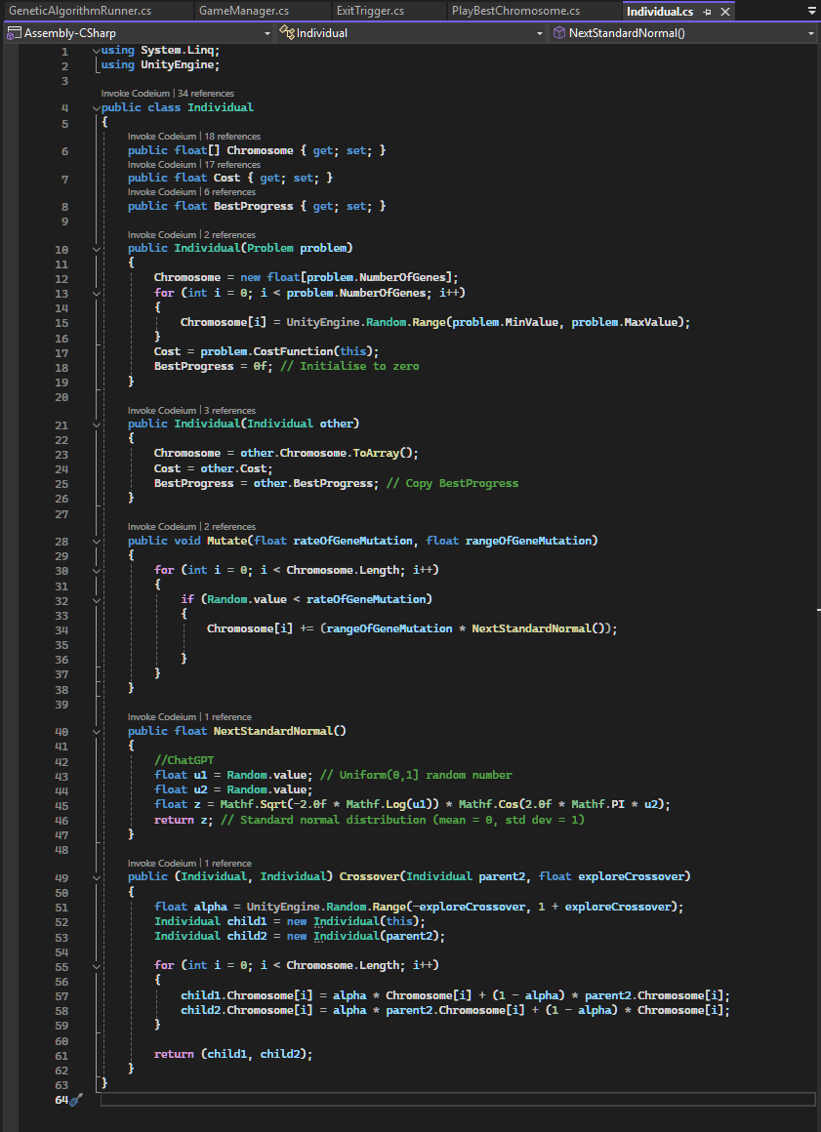

# **Running the Algorithm (~10%)**

## **Parameter Choices**

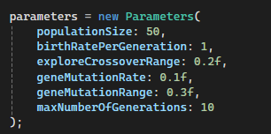

* **Population Size = 50** → Larger population will improve accuracy but take longer.
* **Crossover Exploration = 0.2** → Ensures meaningful genetic diversity.
* **Mutation Rate = 0.1** → Prevents premature convergence.
* **Mutation Range = 0.3** → Only alter inputs minutely -0.3 to 0.3 seconds.
* **Max Generations = 10** → More generations will improve accuracy but take longer.

## **Genetic Algorithm Execution Code**

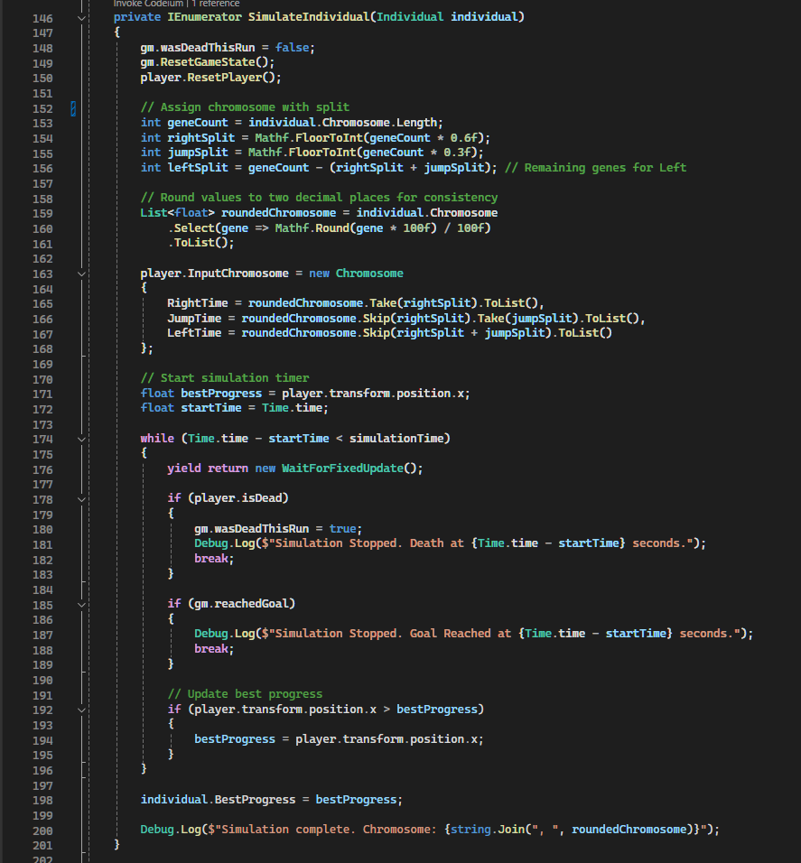

# **Results and Conclusions (~10%)**

## Results

**Progressive Improvement**: Over 10 generations, the AI demonstrated marked progression in navigating the level. By Generation 10 (Figure 6) the AI consistently reached advanced sections of the level, compared to minimal progress in Generation 1 (Figure 5).

**Fitness Function Efficacy**: The progress-based fitness function successfully incentivised fast right movement. However, subtle adjustments, such as reducing penalties for late deaths, inadvertently encourage overly safe behaviour (Figure 8), highlighting the complicated nature of the fitness criteria.

**Parameter Impact**:

* A **mutation rate of 0.1** and **crossover exploration of 0.2** balanced exploration and exploitation, preventing premature convergence while refining viable strategies. In initial tests, these values were higher but led to too many alterations and good runs being negatively altered.
* A **population size of 50** provided sufficient diversity without excessive time, initially a population of 100 was used with a game speed of 20-50x but this caused inconsistencies in the replay function and seemed to cause inaccuracies in the runs. As such as smaller population run at 2x-10x game speed was used for testing.

**Goal Achievability**: While the AI did not surpass the human baseline (12.73 seconds)(Figure 2) in my testing, it consistently achieved a best completion time of below 30 seconds (Figure 4), demonstrating the achievement of a Genetic Algorithm in completing a 2D platformer level, while also highlighting the possibility of further optimisation to closer compete with a human run.

### Challenges and Limitations

**Fitness Function Sensitivity**: Minor changes to the fitness function led to unintended behaviours: e.g. overly safe strategies, underscoring the need for iterative testing and a layered fitness reward structure.

**Physics Inconsistencies**: Rigid body calculations at high simulation speeds, over 10x game speed, caused inconsistencies in chromosome simulating and replay outcomes, reducing reliability. To overcome this a lower game speed was used for the majority of testing as well as rounding the inputs to two decimal places for better consistency.

**Success Direction**: In testing, some runs used suboptimal movement patterns (e.g., excessive jumping, backtracking). A solution such as dynamic mutation rates could mitigate this issue.

### 

### Conclusions

This project validates genetic algorithms as a viable method for 2D platformer AI training while emphasising the importance of careful fitness design and parameter calibration. With refinements, this Genetic Algorithm approach could rival or exceed human performance benchmarks.

**Fitness Design**: Reward structures must be tested to align AI behaviour/ improvements with desired outcomes.

**Parameter Tuning**: Small adjustments to mutation and crossover rates significantly impact alterations of individuals.

**Physics Stability**: Deterministic simulations are crucial for reliable chromosome evaluation, and ensuring movements are calculated in fixed updates at a reliable game speed is crucial.

### Possible Improvements

**Multi-Objective Optimisation**: Include coin collection, back-tracking avoidance and obstacle avoidance as explicit fitness criteria.

**Enhanced Replay Stability**: Reavulate frame-independent physics to ensure consistent chromosome simulation.

**Adaptive Parameters**: Self-adjusting mutation rates based on population metrics could improve evolution speed.

## Issues Discussion

The genetic algorithm is tricky as encouraging and discouraging certain aspects can massively impact the behaviour of the AI. An example is when the fitness function (Figure 5) was configured to not punish dying late as harshly. This was intended to encourage the AI to still make progress without being discouraged so harshly for dying at the end of a good run. This had the unexpected result of encouraging the AI to run about the beginning of the level where it is safe until the time limit was nearing the end, and then attempting to make progress. Examples such as these demonstrate how a small tweak in the fitness function variables can cause rippling effects after many generations of training.

(Figure 6) Shows the replay function with the best Chromosome after 10 generations with 50 individuals in each generation. This displays how the AI did not make any progress until the very end of the Time limit (90 seconds).

Another issue is with the inconsistency in the replay function. The same chromosome can result in different outputs. Rigid body calculations can be inconsistent at such high game speeds. Lower game speeds were used to mitigate this along with ensuring Fixed Updates were used instead of regular Updates which are tied to framerate.

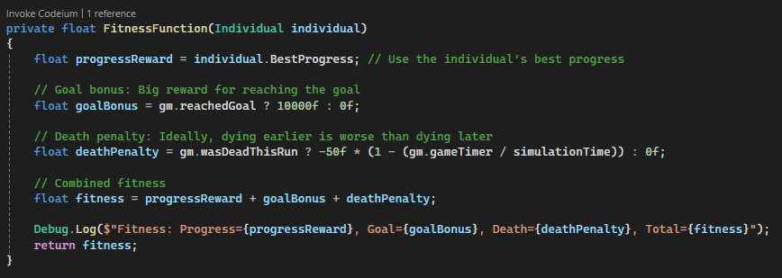

Figure 7: Fitness Function, later death example



Figure 8: Best Chromosome with late death fitness

# Unity Project Creation Process:

A general genetic algorithm Python script (Sheehy, 2025) was used as a basis for this project. Initially, it was planned to integrate the Python genetic algorithm with Unity. There are ways to do this such as embedding Python into Unity using Iron Python (IronPython.net, 2025) (Unknown, 2013). However, this process is quite dated and not widely used or tested on modern versions of Unity. Another alternative would be to use Unity’s Python scripting package (Unity3d.com, 2025). Although doable, these processes would add unnecessary complexity to the project. As such, it was decided to remake the genetic algorithm in C# for Unity.

A simple 2D Platformer was required to test the Genetic Algorithm. A GitHub repository was found (striderzz, 2025) and modified (Elsbury, 2025) for this purpose.

Once the 2D Platformer was cleaned and ready for implementation with a Genetic Algorithm, it was run by a human several times and the best score was recorded. It’s important to note, that this human run could have been refined further, but to test a genetic algorithm it is sufficient. The final baseline time was 12.73 seconds with all 13 coins collected (Figure 1). The goal of this project was not to get the genetic algorithm to beat this time but to get as close as possible using a reasonable population and number of generations.



Figure 2: 2D Platformer Human Run

## C# Genetic Algorithm Explanation

The Genetic Algorithm functions as follows (from the GeneticAlgorithmRunner script):

**Initial Setup**

* A population of random AI players is created.
* Each one gets a **random movement pattern** (chromosome).
* The chromosome (Figure 2) is split into three sequences, each series of numbers represents toggled inputs. Ie: press left for 3.58 seconds, release left for 2.95 seconds.
* These timed inputs for right, left, and jump are compared against the game time and simulated appropriately.

**Simulation & Fitness Evaluation**

* Each AI plays the level in sequence.
* The Game Manager tracks:
  + How far they travelled (BestProgress).
  + If they die (penalty).
  + If they reach the milestone (medium reward).
  + If they reach the goal (big reward).
* A **fitness score** is assigned based on these metrics.
* The fitness score can be altered to include the amount of coins collected as desired.

**Selection & Breeding**

* A percentage of the best-performing AI players are selected for the next generation.
* Individuals are randomly selected from the best fitness players, with some randomness for variation, and **crossed over** to create children.
* Some genes are **mutated** for additional variation.
* A new generation of AI players is created.

**Repeat Until Optimised**

* The previous steps repeat for the desired number of generations.
* Over time, the AI learns better movement patterns.
* Ideally the AI will finish the level (Figure 3) before before the final generation is reached.
* The chromosome that resulted in the best fitness score (Figure 2) is recorded and can be replayed with a UI button.

## Genetic Algorithm Completing Level Example

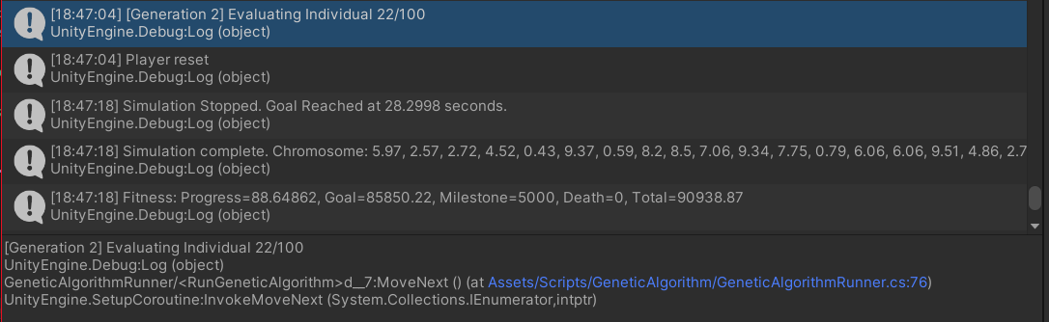

Figure 3: Level Complete Chromosome

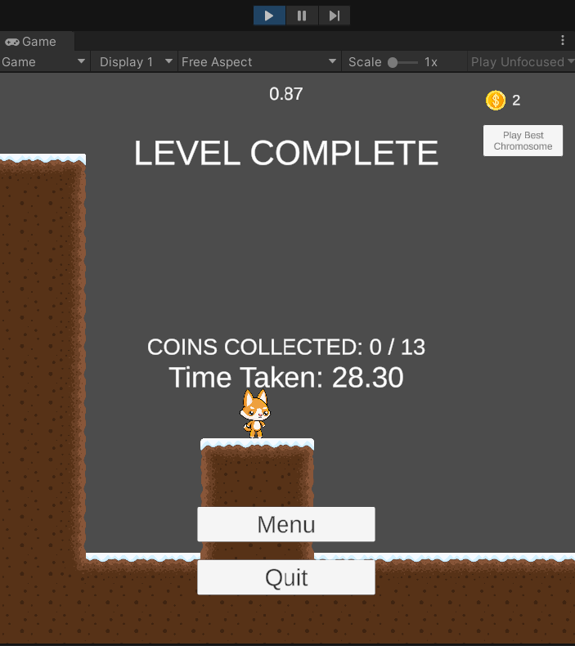

Figure 4: Level Complete Screen

## Genetic Algorithm Running Demonstration

An example of the Genetic Algorithm running at 50x speed (Figure 3) demonstrates the trial-and-error approach the genetic algorithm takes.



Figure 5: Genetic Algorithm Generation 1 - 50x Speed

After 10 Generations the AI can be seen getting much further in the level



Figure 6: Genetic Algorithm Generation 10 - 50x Speed

# List of Figures

Figure 1: Chromosome Example 4

Figure 2: 2D Platformer Human Run 9

Figure 3: Level Complete Chromosome 10

Figure 4: Level Complete Screen 11

Figure 5: Genetic Algorithm Generation 1 - 50x Speed 11

Figure 6: Genetic Algorithm Generation 10 - 50x Speed 12

Figure 7: Fitness Function, later death example 13

Figure 8: Best Chromosome with late death fitness 13

# References

Elsbury, B., 2025. *Billy-Elsbury/2D-Platformer-Unity*. Available at: <https://github.com/Billy-Elsbury/2D-Platformer-Unity> [Accessed 3 March 2025].

IronPython.net, 2025. *IronPython.net /*. [online] Available at: <https://ironpython.net/> [Accessed 3 March 2025].

Sheehy, R., 2025. *AI/2025 at main · Robert-Sheehy/AI*. [online] Available at: <https://github.com/Robert-Sheehy/AI/tree/main/2025> [Accessed 3 March 2025].

striderzz, 2025. *striderzz/2D-Platformer-Unity*. Available at: <https://github.com/striderzz/2D-Platformer-Unity> [Accessed 3 March 2025].

Unity3d.com, 2025. *Python Scripting | Python Scripting | 6.0.1*. [online] Available at: <https://docs.unity3d.com/Packages/com.unity.scripting.python@6.0/manual/index.html> [Accessed 3 March 2025].

Unknown, 2013. Tech Art Survival Guide: Embedding IronPython in Unity = Tech-art hog heaven. *Tech Art Survival Guide*. Available at: <https://techartsurvival.blogspot.com/2013/12/embedding-ironpython-in-unity-tech-art.html> [Accessed 3 March 2025].